Project Planning Phase
Project Planning Template (Product Backlog, Sprint Planning, Stories, Story points)

Date | 08 February 2026
Team ID | LTVIP2026TMIDS66040
Project Name | IntelliSQL: Intelligent SQL Querying with LLMs Using Gemini Pro
Maximum Marks | 5 Marks

Product Backlog, Sprint Schedule, and Estimation (4 Marks) Use the below template to create product backlog and sprint schedule
Sprint | Functional  Requirement (Epic) | User Story  Number | User Story / Task | Story Points | Priority | Team  Members
Sprint-1 | Authentication & DB Setup | USN-1 | User registration and login module | 3 | High | 5
Sprint-1 | Authentication & DB Setup | USN-2 | Secure database  connection  (MySQL/PostgreSQL) | 5 | High | 5
Sprint-1 | Authentication & DB Setup | USN-3 | Display database schema and tables | 5 | Low | 5
Sprint-1 | UI Development | USN-4 | Dashboard for entering natural language queries | 7 | Medium | 5
Sprint-2 | NL to SQL Engine | USN-5 | Convert natural language to SQL using  Gemini Pro | 8 | High | 5
Sprint-2 | Query Processing | USN-6 | Validate generated SQL queries | 5 | High | 5
Sprint-2 | Query Execution | USN-7 | Execute SQL and display results | 5 | High | 5
Sprint | Functional  Requirement (Epic) | User Story  Number | User Story / Task | Story Points | Priority | Team  Members
Sprint-2 | Error Handling | USN-8 | Provide meaningful error messages | 2 | Medium | 5
Sprint-3 | Optimization | USN-9 | Optimize generated SQL queries | 6 | Medium | 5
Sprint-3 | Visualization | USN-10 | Display results in charts/graphs | 6 | Medium | 5
Sprint-3 | History Feature | USN-11 | Maintain query history | 4 | Low | 5
Sprint-3 | Security | USN-12 | Prevent SQL injection and secure execution | 4 | High | 5
Sprint-4 | Testing | USN-13 | Unit and integration testing | 6 | High | 5
Sprint-4 | Performance Testing | USN-14 | Test system with large datasets | 5 | Medium | 5
Sprint-4 | Deployment | USN-15 | Deploy application on cloud/local server | 5 | High | 5
Sprint-4 | Documentation | USN-16 | Prepare technical documentation and user manual | 4 | Medium | 5

Project Tracker, Velocity & Burndown Chart: (4 Marks)
Sprint | Total Story Points | Duration | Sprint Start Date | Sprint End Date (Planned) | Story Points  Completed (as on  Planned End  Date) | Sprint Release Date (Actual)
Sprint-1 | 20 | 7 Days | 20 Feb 2025 | 26 Feb 2025 | 20 | 26 Feb 2025
Sprint | Total Story Points | Duration | Sprint Start Date | Sprint End Date (Planned) | Story Points  Completed (as on  Planned End  Date) | Sprint Release Date (Actual)
Sprint-2 | 20 | 7 Days | 28 Feb 2025 | 06 Mar 2025 | 20 | 06 Mar 2025
Sprint-3 | 20 | 7 Days | 08 Mar 2025 | 14 Mar 2025 | 20 | 14 Mar 2025
Sprint-4 | 20 | 7 Days | 16 Mar 2025 | 22 Mar 2025 | 20 | 22 Mar 2025

Velocity:
Imagine we have a 10-day sprint duration, and the velocity of the team is 20 (points per sprint). Let’s calculate the team’s average velocity (AV) per iteration unit (story points per day)
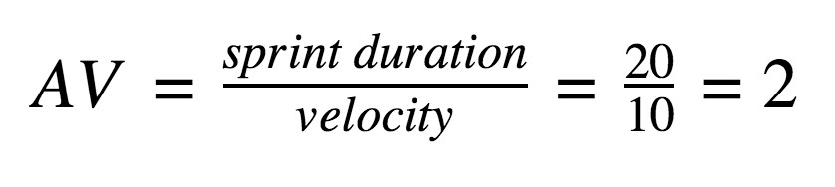

Burndown Chart:
The Burndown Chart represents remaining story points versus time. Each sprint starts with 20 story points. Points reduce daily as tasks are completed, reaching zero by the sprint end date.
https://www.visual-paradigm.com/scrum/scrum-burndown-chart/ https://www.atlassian.com/agile/tutorials/burndown-charts

Reference:
https://www.atlassian.com/agile/project-management
https://www.atlassian.com/agile/tutorials/how-to-do-scrum-with-jira-software https://www.atlassian.com/agile/tutorials/epics https://www.atlassian.com/agile/tutorials/sprints
https://www.atlassian.com/agile/project-management/estimation https://www.atlassian.com/agile/tutorials/burndown-charts

